TABLE OF CONTENTS
1. Introduction ...........................................................................................................6-7
1.1 Problem Statement .........................................................................................6
1.1.1 Overview of Firewall Technologies……………………………………6
1.1.2 Increasing Malicious Network Traffic. ………………………………..7
1.1.3 Need for Blocking Malicious Traffic…………………………………..7
1.2 Related literature ..........................................................................................8-9
1.2.1 Research on IDS/IPS (Snort).................. ………………………………8
1.2.2 Role of Proxy Servers (Squid)................................................................ 8
1.2.3 VPN and Secure Communication (OpenVPN)……………………...... .8

2. Learning Objectives………………………………………………………….…..9.

3. Approach………………………………………………………………………...9-11
3.1 Tools and Technologies Used……………………………………………9
3.2 Infrastructure Setup……………...............................................................10
3.3 Network Setup Diagram…………………………………………………11

4. Implementation………………………………………………………………11-20
4.1 Step-by-Step Execution……………………………………………… ..11
4.2 Screenshots and Logs ............................................................................ .12
4.3 Indicators of Compromise (IoCs) ........................................................... 19
5. Conclusion & Recommendations…………………………………………..…20-21

6. List of References ...............................................................................................21

- Implementing and Studying Firewall Technologies for Blocking Malicious Traffic

  - Problem Statement:

“Implementing and Studying Firewall Technologies for Blocking Malicious Traffic”

Modern networks are increasingly targeted by malicious traffic, including adware, spyware, phishing, and unauthorized access attempts. Traditional firewalls, with their limited rule-based filtering, often fail to detect and block these sophisticated threats.

Addressing these challenges requires the implementation of advanced firewall technologies such as Snort (IDS/IPS), Squid Proxy, and OpenVPN to enhance threat detection, content filtering, and secure communication within network environments.

    - Overview of Firewall Technologies:

Firewalls are essential components of modern network security systems. They serve as the first line of defense by monitoring, filtering, and controlling incoming and outgoing network traffic based on defined security rules. Firewalls help prevent unauthorized access, mitigate cyber threats, and protect sensitive data from malicious actors.

There are various types of firewall technologies that serve different purposes:

- Intrusion Detection and Prevention Systems (IDS/IPS): These systems monitor network traffic for suspicious patterns and can either alert administrators (IDS) or take automated action (IPS) to prevent the threat.

- Proxy Servers: These act as intermediaries between users and the internet, filtering web content, blocking unwanted domains, and improving privacy.

- Virtual Private Networks (VPNs): VPNs encrypt internet traffic to provide secure remote access and prevent interception of data on public or untrusted networks.
With the increasing complexity of cyber threats, a layered firewall approach using IDS/IPS, proxies, and VPNs offers more robust protection than traditional firewalls alone.

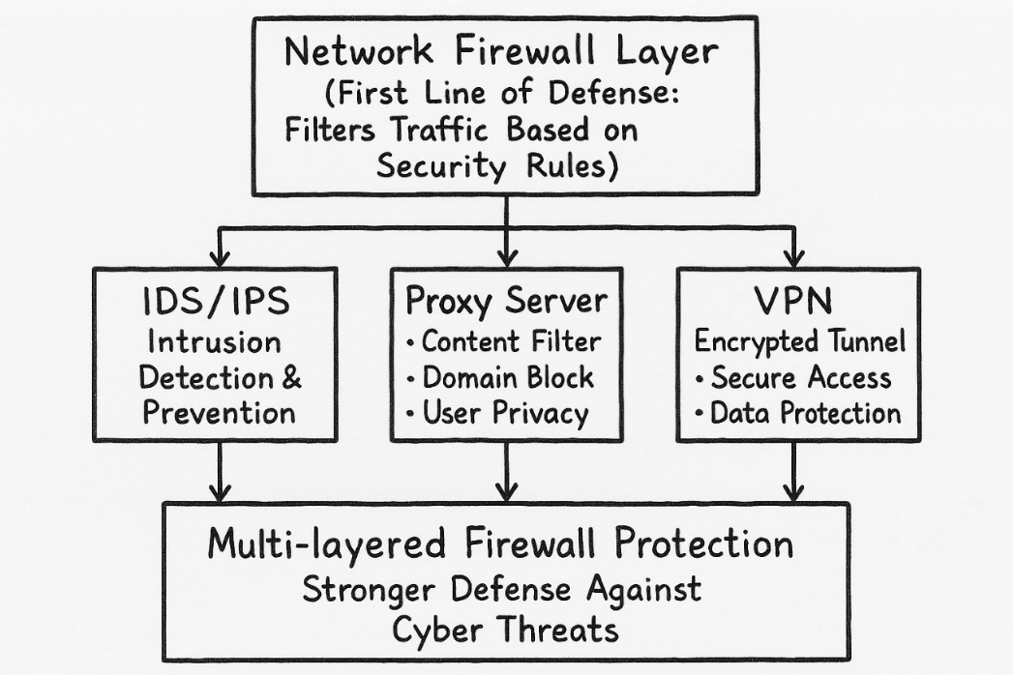

    - Increasing Malicious Network Traffic:

The rapid expansion of digital networks has led to a significant rise in malicious traffic targeting users, systems, and organizations. Cyber threats such as adware, spyware, ransomware, phishing, and trojans are now common and often disguised within regular traffic, making them harder to detect. These threats not only aim to steal sensitive data but can also hijack systems, cause service outages, and severely impact business continuity.
Malicious traffic frequently bypasses conventional security systems due to its evolving nature and ability to exploit unpatched vulnerabilities. As a result, there is a growing demand for more advanced and adaptive firewall solutions capable of identifying and mitigating these threats in real time.

    - Need for Blocking Malicious Traffic:
With the rise in cyber threats, blocking malicious traffic has become essential for protecting networks and ensuring data security. Malicious traffic, if left unfiltered, can compromise systems, steal sensitive information, and disrupt services. Basic firewalls alone are no longer sufficient to defend against advanced threats.
Key reasons include:
- Protects against adware, spyware, phishing, and trojans
- Prevents unauthorized access to internal systems
- Reduces the risk of data breaches and information leakage
- Maintains service availability and network performance
- Supports compliance with cybersecurity standards
A multi-layered firewall approach helps in proactively identifying and blocking such traffic before it causes harm.

  - Related Literature:
Firewalls are a fundamental part of network security systems, designed to monitor and control incoming and outgoing traffic based on security rules. They act as a barrier between trusted internal networks and untrusted external sources. Advanced firewall technologies, such as IDS/IPS, proxies, and VPNs, enhance this protection by adding layers of detection, filtering, and encryption.

    - Research on IDS/IPS (Snort):
Snort is a widely adopted open-source Intrusion Detection and Prevention System (IDS/IPS) used to monitor and analyze network traffic in real-time. It operates on a rule-based system to detect and respond to malicious patterns. Various research studies and practical deployments have proven Snort's reliability and flexibility in securing networks.
Key findings from related literature:
- Detects known threats using signature-based rules.
- Can operate in IDS mode (alert-only) or IPS mode (actively blocks threats).
- Supports real-time traffic logging and alerting.

    - Role of Proxy Servers (Squid):
Proxy servers act as intermediaries between client systems and the internet, helping regulate, monitor, and secure traffic. Squid is a widely used open-source proxy server known for its efficiency and customizability. It enhances both performance and security within enterprise networks.
- Caches web content to reduce bandwidth usage and load times.
- Filters web access based on IP, domain, keywords, or URLs.
- Blocks malicious or restricted websites before they reach users.

    - VPN and Secure Communication (OpenVPN):
VPNs create encrypted tunnels for secure communication over untrusted networks like the internet. OpenVPN is a powerful and widely adopted open-source VPN tool used to protect data and maintain privacy during remote or site-to-site communication.
- Encrypts all data traffic to protect it from eavesdropping.
- Authenticates users using certificates or credentials.
- Supports remote access for secure connection to internal networks.

2. Learning Objectives:

This project aims to provide practical and theoretical understanding of how firewall technologies function to secure networks from malicious traffic. The primary learning objectives include:
- To understand the core principles of firewall technologies and how they contribute to network security.
- To explore various types of firewalls such as packet filtering, stateful inspection, and proxy-based firewalls.
- To identify different forms of malicious network traffic and the threats they pose to organizational networks.
- To implement and configure open-source security tools like Snort (IDS/IPS), Squid (Proxy), and OpenVPN (VPN).
- To analyze the effectiveness of firewall setups in detecting and blocking malicious activities.
- To learn how to interpret firewall logs and indicators of compromise (IoCs) for better threat analysis.
- To build a secure network environment through layered defense mechanisms integrating firewall, proxy, and VPN solutions.

3. Approach:

3.1 Tools and Technologies Used:
- Virtualization Platform:
  - VirtualBox (to run Kali Linux)

- Operating Systems:
  - Kali Linux

- Scripting:
    - Bash (for basic automation)

- Firewall Technologies
• Snort-- (Intrusion Detection and Prevention System)
To detect and alert/block adware and malicious traffic.
• Squid Proxy Server--To filter and block access to known adware domains.
• OpenVPN--To create a secure encrypted tunnel for client traffic.
- Monitoring and Testing Tools
    - Wireshark (optional but recommended)
To capture and analyze network packets and verify traffic filtering.

3.2 Infrastructure Setup:
A virtual network environment was created using VirtualBox. Two virtual machines were set up: one as the firewall server and the other as the client.
The firewall server runs Kali Linux with Snort, Squid Proxy, OpenVPN, and Wireshark installed. This server acts as a gateway to monitor, filter, and secure all traffic coming from the client.
The client machine runs Windows or Linux and is configured with a web browser and OpenVPN client. All client traffic is routed through the firewall server for inspection.
Both virtual machines are connected using VirtualBox’s Host-Only Network. This network isolates the VMs from the host and external networks while allowing communication between them.
The client’s traffic is encrypted using OpenVPN and sent to the firewall server. Squid Proxy filters the traffic to block access to known adware websites. Snort monitors network traffic to detect and alert on suspicious or malicious activity. Wireshark is used on the firewall server to capture and analyze the network traffic during testing.
This setup provides a safe and controlled environment to implement and evaluate firewall technologies for blocking adware.

3.3 Network Setup Diagram:
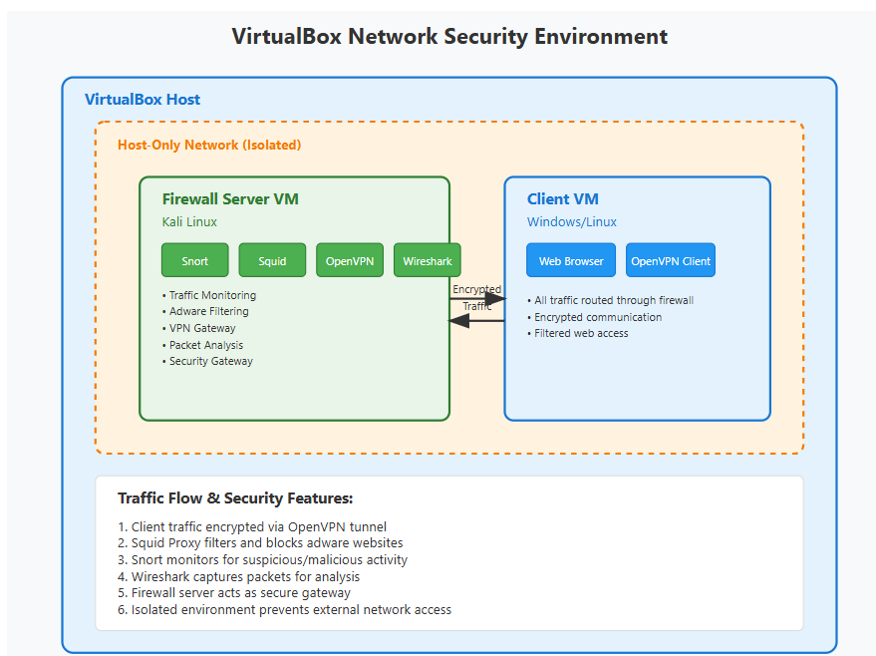

4. Implementation:

4.1 Step-by-Step Execution:

- Install virtual box
- Install Kali Linux on VirtualBox
- Update Kali Linux packages.
- Install Snort on Kali Linux.
- Configure Snort for your network.
- Run Snort to monitor traffic.
- Install and configure Squid Proxy Server.
- Set up Squid to block adware domains.
- Install and configure OpenVPN server on Kali Linux.
- Set up OpenVPN client on the client machine.
- Configure client’s browser to use Squid proxy.
- Connect client to OpenVPN and route traffic through the firewall server.
- Monitor and analyze traffic using Snort and Wireshark.
- Review logs to verify blocking of adware and detection of malicious traffic.

4.2 Screenshots and Logs


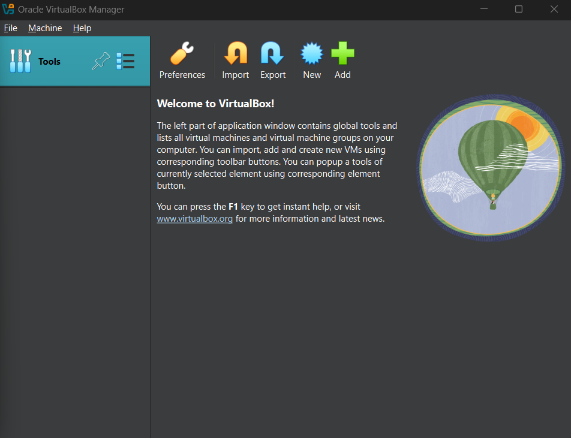
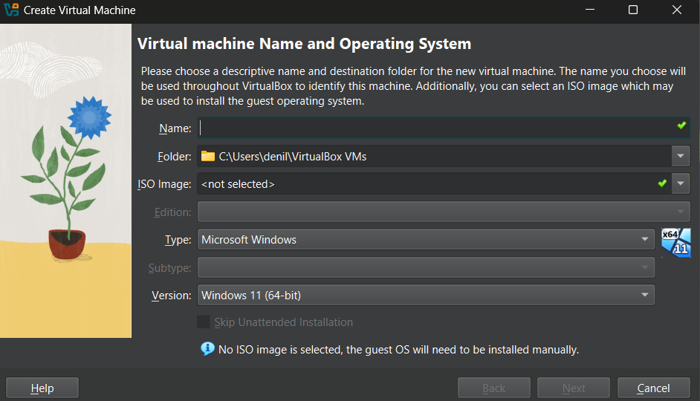





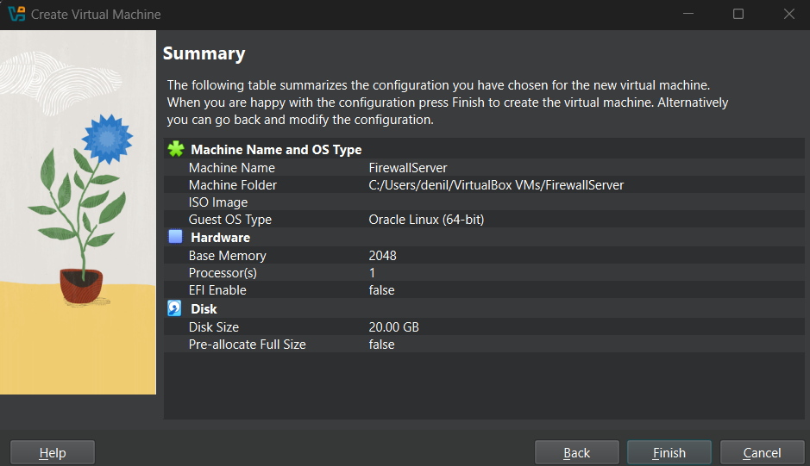

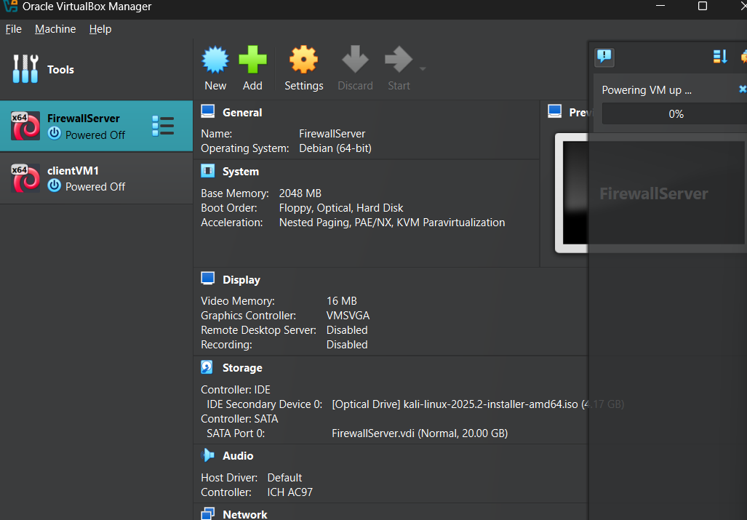

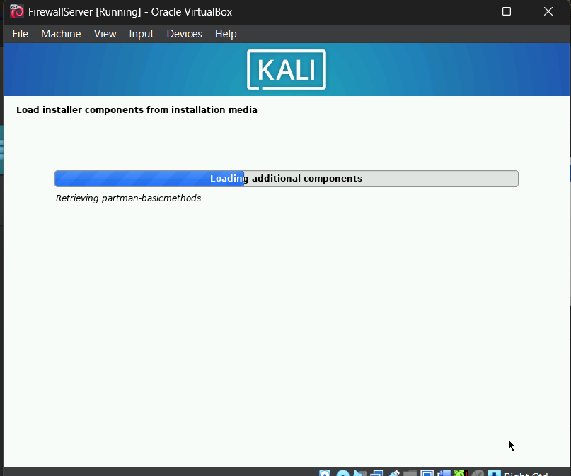

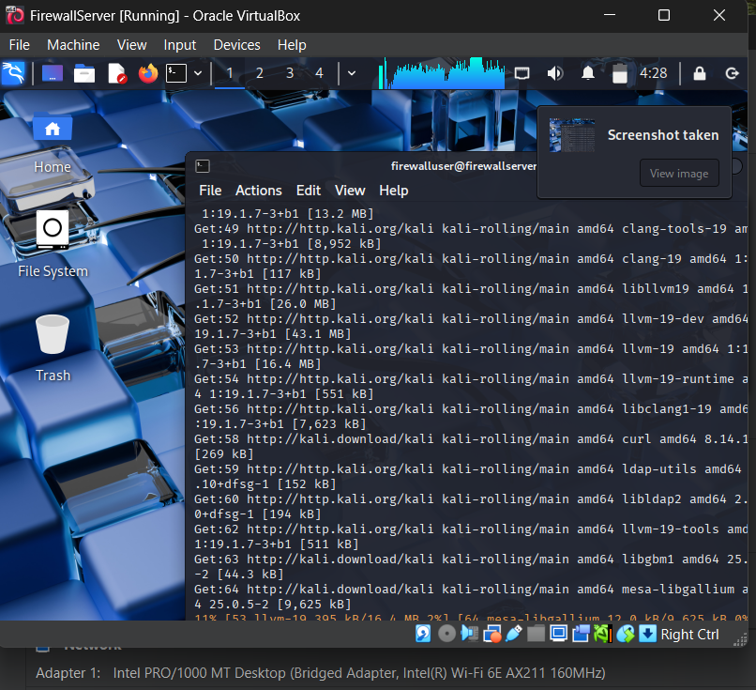

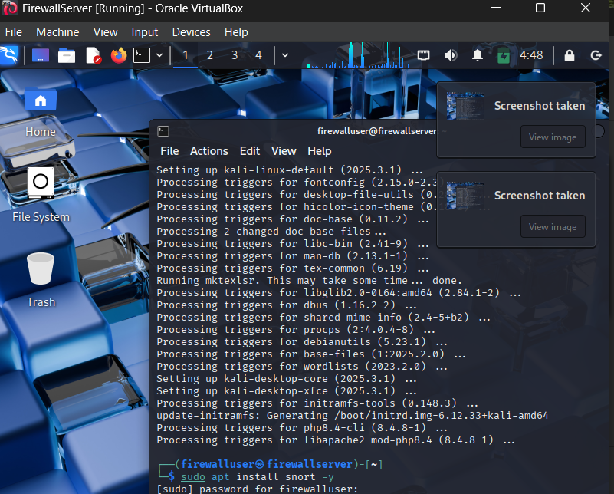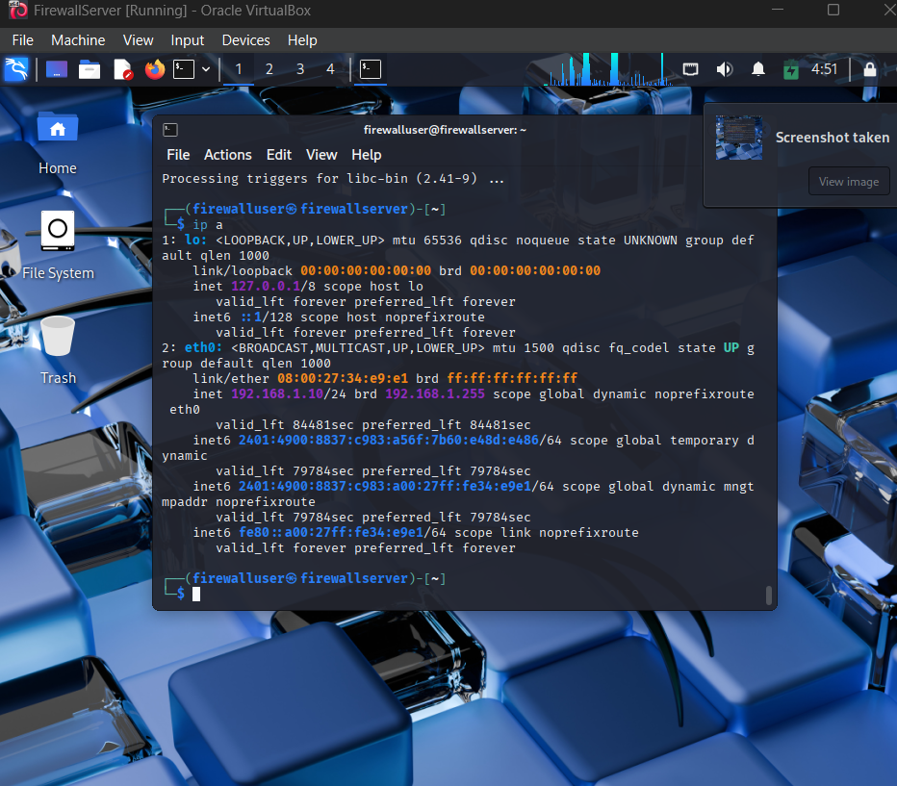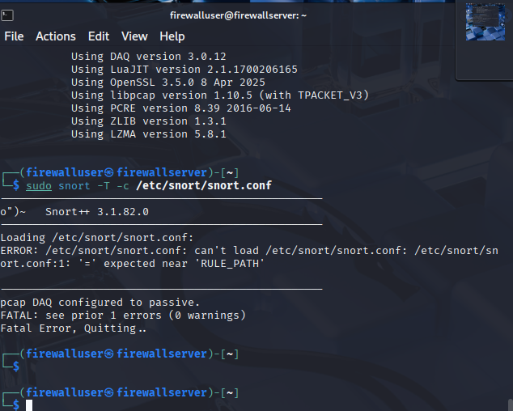

4.3 Indicators of Compromise (IoCs):

- Snort Alerts
  - High or unusual number of alerts triggered.
  - Signature matches for known malware or exploits (e.g., port scans, buffer overflows, suspicious payloads).
  - Repeated alerts from the same IP addresses or ports.
- Suspicious Network Traffic (via Wireshark or Snort logs)
  - Unexpected outbound traffic to unknown IPs or domains.
  - Traffic on uncommon ports (e.g., 1337, 4444).
  - Encrypted traffic (SSL/TLS) to suspicious destinations.
  - DNS tunnelling activity.
- Proxy Logs (Squid)
  - Access attempts to blocked or blacklisted domains (e.g., adware/malware sites).
  - Repeated requests to known adware domains.
  - HTTP error codes like 403 (Forbidden) or 407 (Proxy Authentication Required).
- VPN Logs (OpenVPN)
  - Unusual login times or IP addresses.
  - Unexpected client configurations or session durations.
  - Attempts to bypass VPN routes.
- System and Application Logs (Kali/Client OS)
  - Unauthorized login attempts or privilege escalations.
  - New or modified startup scripts (possible persistence mechanisms).
  - Suspicious processes or binaries running on the client.
- File System Artifacts (on Client or Server)
  - Presence of unusual files or executables.
  - Known malware hash matches (MD5/SHA256).
  - Changes in system files or configuration.
- Behavioural Anomalies
  - Sluggish system performance or crashes.
  - Unexpected reboots or services stopping.
  - Browser redirects or popup ads (signs of adware infection).

These IoCs can help you validate the effectiveness of your firewall, Snort rules, and Squid proxy filtering. You can correlate findings from Snort, Wireshark, Squid logs, and system logs to detect and understand the nature of the attack.

5. Conclusion & Recommendations:
The implementation and study of firewall technologies—Snort (IDS/IPS), Squid Proxy Server, and OpenVPN—demonstrated effective blocking and detection of adware and malicious network traffic. The virtualized environment allowed safe testing and analysis of traffic filtering, alerting, and encryption. Snort successfully detected suspicious activity, Squid efficiently blocked access to known adware domains, and OpenVPN secured client-server communication by encrypting traffic. This combination provides a strong defense against adware and enhances overall network security.
Recommendations
- Regularly update firewall rules and proxy access lists to keep up with emerging adware threats.
- Continuously monitor network traffic using tools like Snort and Wireshark for early detection of new malicious patterns.
- Implement VPN solutions like OpenVPN in environments requiring secure remote access to protect data privacy.
- Consider integrating additional security layers such as endpoint protection and regular security audits to strengthen defenses.
- Train users about safe browsing habits to reduce the risk of encountering adware and other malware.

6. List of References:

- Roesch, M. (1999). Snort - Lightweight Intrusion Detection for Networks. Proceedings of the 13th USENIX Conference on System Administration (LISA '99), 229-238.

- Squid-Cache.org. (2023). Squid Proxy Server Documentation. Retrieved from https://docs.squid-cache.org/

- OpenVPN Technologies, Inc. (2023). OpenVPN User Manual. Retrieved from https://openvpn.net/community-resources/how-to/

- Understanding IDS/IPS: Intrusion Detection and Prevention Systems

- Proxy Server Configuration Guide: Squid Proxy Server

- VPN Implementation Guide: OpenVPN Documentation

- Wireshark Foundation. (2023). Wireshark User Guide.
Retrieved from https://www.wireshark.org/docs/wsug_html/

- Bejtlich, R. (2013). The Practice of Network Security Monitoring. No Starch Press.

